**HBase Assignment 1 -Task 2:**

ssbyvarioususer – Hbase Table name

**Access the hbase data from hive**

For the above hbase table create a corresponding hive table and access the data by running queries in hive

CREATE EXTERNAL TABLE ssbyvarioususerToHBase(rowkey string, stock_symbol string, commented string, userid string,

displayname string, active string, comment string)STORED BY 'org.apache.hadoop.hive.hbase.HBaseStorageHandler'WITH SERDEPROPERTIES ('hbase.columns.mapping' = ':key,info:stock_symbol,info:commented,info:userid,info:displayname,info:active,info:comment')TBLPROPERTIES ('hbase.table.name' = 'indhudb:ssbyvarioususer');

Select * from ssbyvarioususerToHBase;

1.What are the various comments given by all the users?

select distinct userid,comment from ssbyvarioususerToHBase;

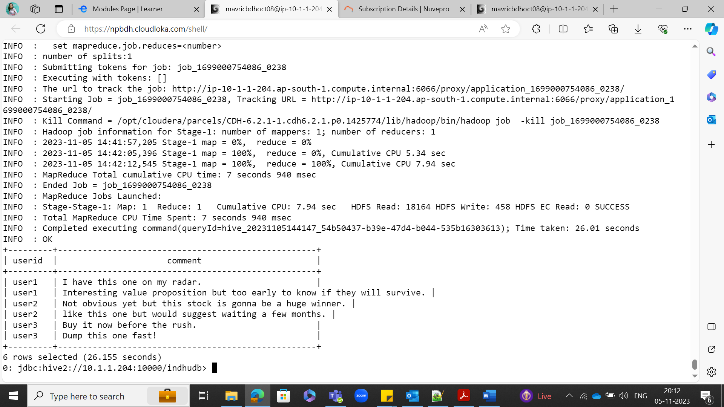

**2.What are the comments by user3?**

select userid,comment from ssbyvarioususerToHBase where userid='user3';

**3.Which users have inactive comments?**

select userid from ssbyvarioususerToHBase where active='False';

